Chapter 19, Solution 74.

From Prob. 18.35, the transmission parameters for the circuit in Figs. (a) and (b) are

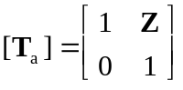, 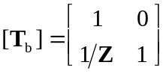
(b)
Z
(a)

Z

We partition the given circuit into six subcircuits similar to those in Figs. (a) and (b) as shown in Fig. (c) and obtain 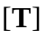 for each.
s
1
1
1/s
T₁
T₃
T₂
T₄
T₆
T₅
s
1/s

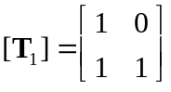, 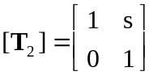, 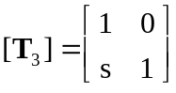

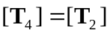, 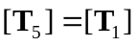, 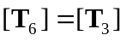

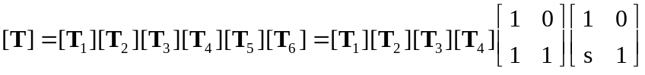

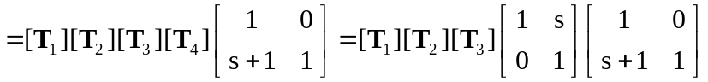

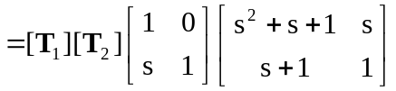

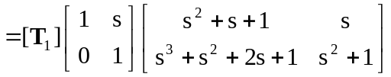

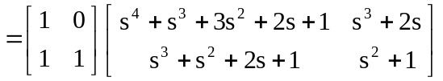

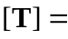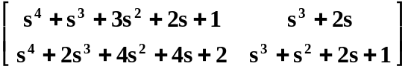

Note that 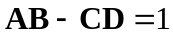 as expected.

